**HOODIES FOR HOLIDAY- HOST COMMITTEE EMAIL**

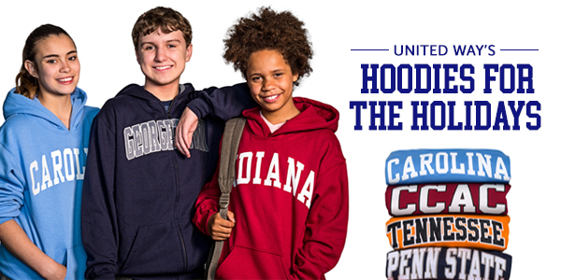

To:

Subject: Help a Middle School Student dream big for their future this holiday season

Dear [NAME],

The holidays may seem far away. But before we know it, the weather will be colder and once again it will be time to share some warmth (along with some school spirit) in support of United Way’s Hoodies for the Holidays volunteer event.

You can help provide deserving middle schoolers in our area with a new college hoodie for the holidays. It will help keep them warm and also inspire them to see themselves as a future college student and graduate.

I’m proud to be part of United Way’s Hoodies For The Holiday’s host committee, and I’m asking you to show your pride (of your alma mater and our community). You can support this event in one of three ways:

1. Donate a new college hoodie or make a pledge of $30 and United Way will do the shopping. You can visit [app.mobilecause.com/vf/HOODIES18](https://app.mobilecause.com/vf/HOODIES18) to make your donation.
2. Register to volunteer at our Hoodies For The Holiday’s wrap Party on November 28th at Heinz Field. There will be food, networking, and a special celebrity guest. Register at [Hoodies18.org](https://volunteer.uwswpa.org/opportunity/a3B0G000000BTkK)
3. Start a Hoodie Drive at the office. Encourage a little collegiate rivalry and inspire a middle schooler to dream big. Click the link below to access our campaign toolkit for setting up your hoodie drive: [bit.ly/Hoodies18Toolkit](https://uwswpa.org/hoodies-for-the-holidays-2018-toolkit/?utm_campaign=hoodies18-toolkit&utm_source=print&utm_medium=print)

The goal this year is to provide 400 middle schoolers with hoodies and I am personally committed to securing at least (host committee member to fill in amount here) with help from friends and associates like you.

Thank you for your support of United Way and local middle school students – during the holidays and throughout the year.

Warm wishes,